FULL PAPER TITLE (TIMES NEW ROMAN, 12 PT, CENTERED)
Provide a concise, informative, and specific title that clearly reflects the main focus, method, or contribution of the study. Avoid overly broad or vague expressions.
The full paper must be between 4,000 and 7,000 words, excluding references.
Abstract
(300–500 words recommended)
The abstract should provide a clear and structured summary of the study. It is recommended that the abstract addresses the following elements in a single, coherent paragraph:
- Purpose / Problem: Clearly state the main research problem or objective of the study.
- Context: Briefly describe the theoretical, empirical, or practical context of the research.
- Methodology: Indicate the research design, data sources, sample, and analytical approach.
- Findings (if available): Summarize the most important results or expected outcomes.
- Contribution: Explain the study’s contribution to the literature and/or practice, particularly in relation to Sustainability and Artificial Intelligence.
The abstract should be self-contained and understandable without reference to the full paper.
Keywords
Provide 3–5 keywords that reflect the main themes, methods, and scope of the study.
Keywords should be written in lowercase (except proper nouns) and separated by semicolons.
Example:
sustainability; artificial intelligence; decision support systems; circular economy
Graphic Abstract
(Required for Full Paper Submissions)
Authors are required to include a Graphic Abstract that visually summarizes the main objective, methodology, and key contribution of the study. The graphic abstract should provide a clear, concise, and self-explanatory overview of the research and should be understandable without extensive explanatory text.
The graphic abstract may include conceptual frameworks, process diagrams, flowcharts, or other visual representations relevant to the study. The use of minimal text is recommended, with emphasis on visual clarity.
Formatting Guidelines:
- Single visual only
- Preferred file formats: JPG, PNG, or PDF
- Minimal text: visuals should be self-explanatory
- Suitable for digital display
Example Graphic Abstract:
(For illustration purposes only)
The following example is provided to illustrate the expected format and level of detail for a graphic abstract.
Authors must replace this example with their own original graphic abstract.
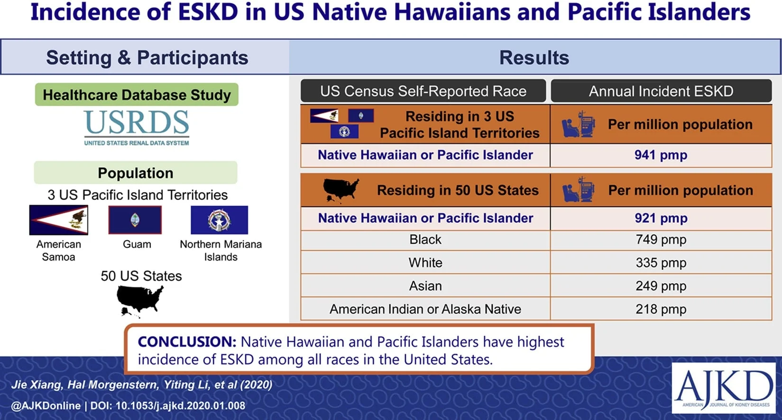
Incidence of ESKD Among Native Hawaiians and Pacific Islanders Living in the 50 US States and Pacific Island Territories
Example adapted from graphical abstract guidelines and samples provided by Elsevier Author Tools & Resources.
Introduction
This section introduces the study in detail and establishes its academic relevance. It should include:
- A clear description of the research problem or gap
- The motivation and significance of the study
- The broader context of Sustainability and AI (or related theoretical frameworks)
- A brief review of key literature relevant to the topic
Research questions, hypotheses, or study objectives should be explicitly stated at the end of this section.
Literature Review
This section provides a critical and structured review of the existing literature relevant to the research topic. The purpose of the literature review is not only to summarize prior studies, but also to position the current research within the existing body of knowledge. The literature review should include:
- An overview of key theoretical frameworks, concepts, and models related to the study
- A synthesis of relevant empirical studies, highlighting major findings and methodological approaches
- Identification of gaps, inconsistencies, or limitations in existing literature
- A clear justification of how the present study contributes to or extends previous research
The literature review should demonstrate the author’s familiarity with the academic field and establish a strong foundation for the research questions, hypotheses, or objectives presented in the study.
Method(s)
This section describes how the research was conducted. Authors should clearly explain the methodological approach used in the study. Where appropriate, the section may be structured using subheadings such as:
- Research design (qualitative, quantitative, mixed methods, etc.)
- Flow chart
- Data collection procedures and instruments
- Data analysis techniques
- Sample or data set
The description should be sufficiently detailed to allow readers to understand and evaluate the rigor of the study.
Findings
This section presents the results of the study in a clear and logical manner. Findings should directly address the research questions and/or hypotheses.
- Use tables and figures where appropriate
- Ensure that all tables and figures follow APA 7th Edition formatting rules
- Avoid interpretation in this section; focus on reporting results
Discussion
The discussion section interprets the findings and situates them within the existing literature. Authors are encouraged to address:
- How the findings relate to previous research
- Theoretical and/or practical implications of the results
- Contributions to Sustainability and AI scholarship
- Limitations of the study and directions for future research
This section should clearly articulate how the study advances academic or practical understanding.
Author Contributions
This section describes the individual contributions of each author to the study. Contributions may include, but are not limited to, conceptualization, methodology, data collection, analysis, writing, and review. This section should be completed after acceptance to maintain the integrity of the double-blind review process.
Data Availability Statement
This section provides information on the availability of the data used in the study. Authors should indicate whether the data are publicly available, available upon reasonable request, or not available due to ethical, legal, or confidentiality restrictions.
Example statements:
- The data supporting the findings of this study are available upon reasonable request from the corresponding author.
- The data are publicly available at [repository name / link].
- Data sharing is not applicable to this study.
Funding / Scholarship Information
This section should disclose any financial support, grants, scholarships, or funding sources that supported the research. If no funding was received, authors may state this explicitly. This information should be added after acceptance to ensure double-blind review.
Example:
- This research received no external funding.
- This study was supported by [Funding Agency, Grant Number].
Practical Implications
This section discusses the practical applications of the research findings. Authors should explain how the results may be used by practitioners, policymakers, organizations, or other stakeholders, particularly in relation to Sustainability and Artificial Intelligence.
Future Research Directions
This section outlines potential avenues for future research arising from the study’s findings and limitations. Authors may suggest theoretical extensions, methodological improvements, or new research questions for subsequent studies.
References
(APA 7th Edition)
List all sources cited in the manuscript following APA 7th Edition guidelines. Only works cited in the text should be included. References must be complete, accurate, and alphabetized by the author’s last name.

